Publicity Overrides

Publicity override can be used to publish or unpublish one region at a time to search or Opensimworld.com
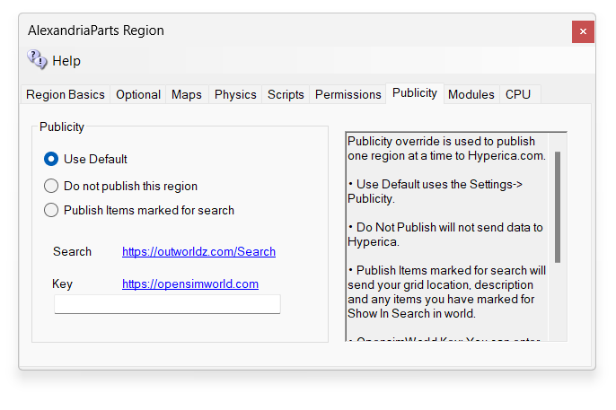
Use Default uses the Settings->Publicity.
Do Not Publish will not send data to Hyperica.
Publish Items marked for search will send your grid location, description and any items you have marked for Show In Search in world.
OpensimWorld Key: You can enter your OpensimWorld key here for this region. Then you do not need the scripted box. Also, and Smart Boot Regions will be reported as online even when powered down or frozen.

